Princess Sumaya University for Technology

King Abdullah II Faculty of Engineering

Electrical Engineering Department



|  |
| --- |
| **firefighting robot** |

|  |  |  |  |
| --- | --- | --- | --- |
| *Authors:* |  |  | *Supervisor:* |
| Motasem amaireh  Almuthanna Alawwad  Abdallah Juma | 20190430    20180796  20190513 | Electrical power and Energy engineering  NIS  Electrical power and Energy engineering | Dr.Belal Sababha |

*May 26, 2024*

***Abstract***

**This firefighting robot’s objectives are to travel straight when facing a fire, steer freely in the direction of any detected fire, and precisely spray water when it gets near to the fire. The servo motor controls the hose. An ultrasonic sensor to avoid running into objects when moving straight ahead. Effective and cautious responses to a variety of firefighting circumstances are ensured by the integrated architecture. There are four flame sensors in the smart firetruck. Three 3.7V batteries, a PIC 16F877A microprocessor, an ultrasonic sensor, and a water system comprising a tank, pump, and servo motor.**

Table of Contents

1 Introduction 2

1.1 Background 2

2 Design 7

3 Problems and recommendations 11

3.1 problems 11

3.2 Recommendations 11

4 Conclusions 11

# Introduction

This project tackles the development of an automated fire fighting truck which utilizes the Microchip PIC16F877A microcontroller as its central processing unit.

This project's main goal is to build a firetruck that can detect fires on its own and react by applying targeted water suppression. In order to accomplish this, the project combines motorized propulsion, a servo motor-controlled water system, and the flame sensor module KY-026 for fire detection in order to precisely identify flames and provide water.

This report details the autonomous firefighting truck's conception, execution, and assessment, emphasizing the difficulties encountered and the answers found during the project's development. Through an examination of the technological details and lessons discovered, this documentation seeks to offer insights into the development of a robotic system designed to successfully and independently tackle flames.

## Background

The PIC16F877A microcontroller, manufactured by Microchip Technology Inc., stands as a cornerstone in the realm of embedded systems and microcontroller applications. Launched as part of Microchip's PIC16 family, the PIC16F877A has garnered widespread acclaim for its versatility, robustness, and ease of use.

A potent 8-bit RISC (Reduced Instruction Set Computer) architecture with an improved mid-range core and an extensive array of integrated peripherals is at the core of the PIC16F877A. This microcontroller, which can operate at up to 20 MHz, provides sufficient processing capacity for a variety of uses, such as consumer electronics, industrial control, and robotics in our instance.

The PIC16F877A stands out because to its extensive array of onboard peripherals, which includes timers, analog-to-digital converters (ADC), USART (Universal Synchronous Asynchronous Receiver Transmitter) modules, and many others. These add-ons give programmers the basic components they need to connect to external sensors, exchange data with other devices, and carry out a wide range of functions with little additional hardware.

The KY-026 flame sensor module is a compact and efficient component designed for fire detection applications. Equipped with a sensitive photodiode and amplifier circuitry, it detects infrared (IR) light emitted by flames, generating a digital output signal to indicate their presence. Its simplicity of use, standardized pinout, and affordability make it a popular choice for integrating fire detection capabilities into various electronic projects, including our firefighting truck.

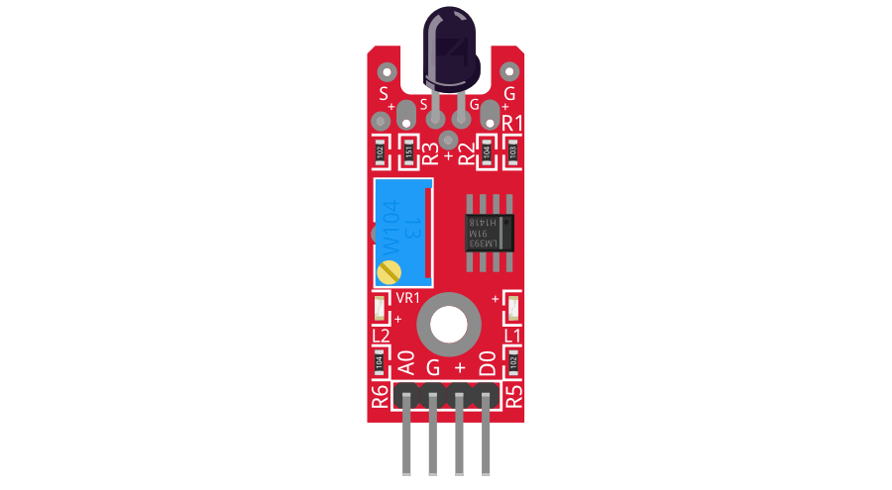

Figure 1 KY-026

The SG90 servo motor is a compact and powerful actuator commonly used in robotics and electronic projects. It offers precise motion control with a rotation range of up to 180 degrees, making it suitable for tasks requiring fine-grained movement. Operating on a PWM signal, it can be easily integrated with microcontrollers and Arduino boards. With its small size, low power consumption, and affordability, the SG90 servo motor is a popular choice for a wide range of applications.

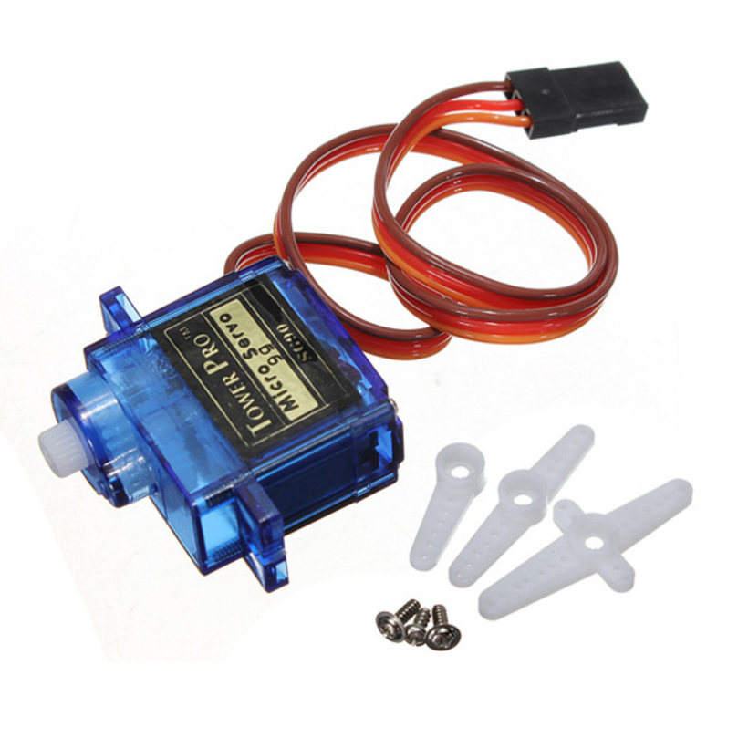

Figure 2 Servo motor

The HC-SR04 ultrasonic sensor is a commonly used component for measuring distance in electronic projects. It emits ultrasonic waves and measures the time it takes for them to bounce back from nearby objects, allowing for accurate distance calculations without physical contact. This sensor is easy to use, low-cost, and suitable for a variety of applications including robotics, obstacle detection, and proximity sensing.

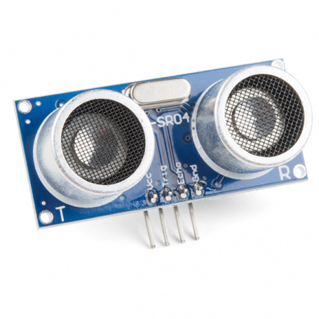

Figure 3 HC-SR04

The submersible water pump is a compact device designed to pump water in various applications, such as aquariums and hydroponic systems. Operating on DC voltage between 3V and 5V, it is suitable for low-power setups. Despite its small size, it offers efficient water movement and quiet operation, making it ideal for small-scale water pumping tasks.

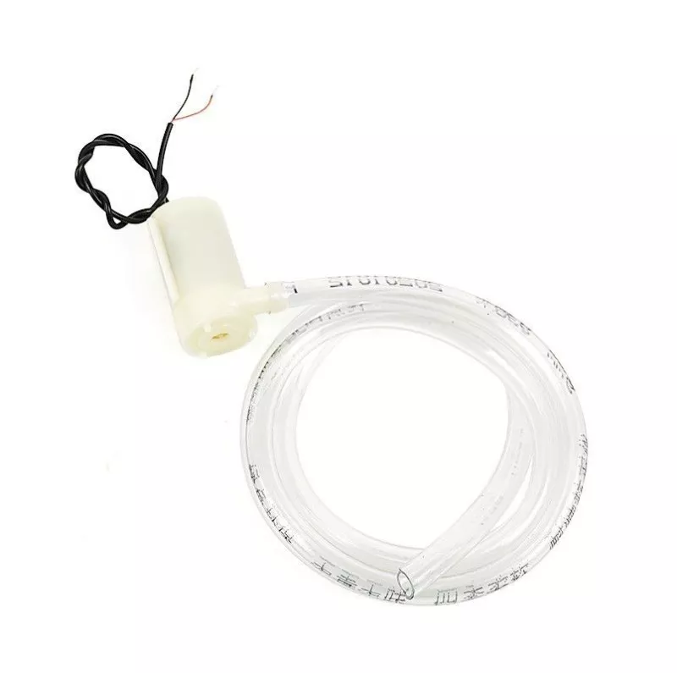

Figure 4 Water pump

The 5V 1-channel relay module with optocoupler is an electronic component used to control high-power devices with low-voltage signals. It integrates a relay and an optocoupler to switch the flow of electrical current to a connected load on and off. Operating at 5V, it is compatible with a wide range of microcontrollers and electronic devices, making it a popular choice for various projects.

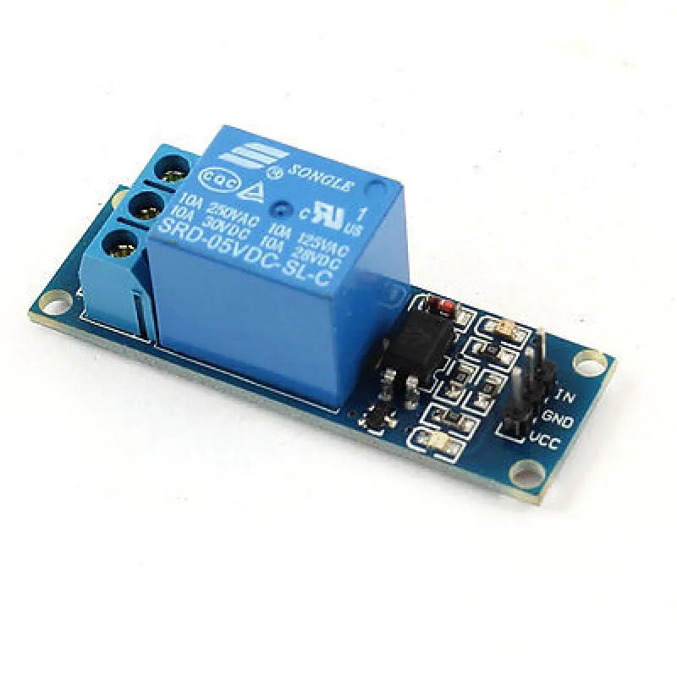

Figure 5 5V channel relay module

The PIC 16F877A is a versatile and widely-used microcontroller manufactured by Microchip Technology. With an 8-bit RISC architecture and clock speed of up to 20 MHz, it offers a rich set of integrated peripherals for a wide range of applications. Known for its reliability and ease of use, it is commonly employed in industrial automation, consumer electronics, and various embedded systems projects.

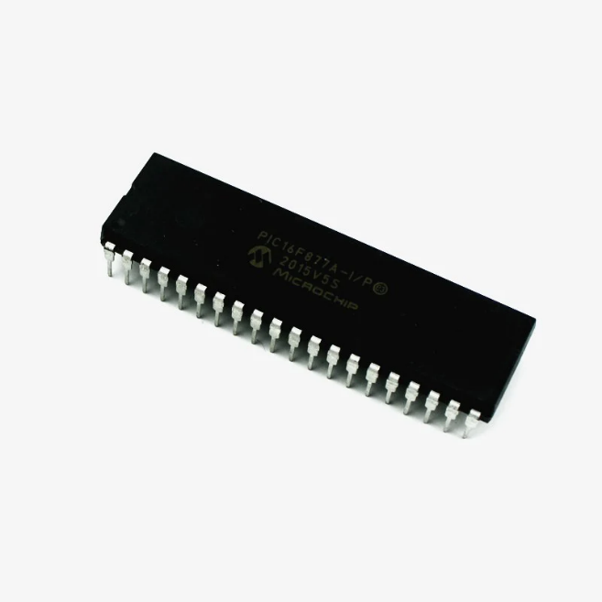

Figure 6 PIC 16F877A

# Design

To detect the presence of a fire readings from all sensors are taken and analyzed by the microchip PIC16F877A. In the case a fire is detected the fire truck moves in the directions of the fire and water from the attached water tank is sprayed continuously until the fire is no longer detected.

Figure 7 shows the design of the firetruck. As shown, sensors detect nearby fire so that the firetruck can move in the direction if the fire to get to a calculated distance, then water is pumped from water tank using the pump connected to a servo motor that moves the pump left and right to increase the span covered by the water for efficient putting out of the fire.

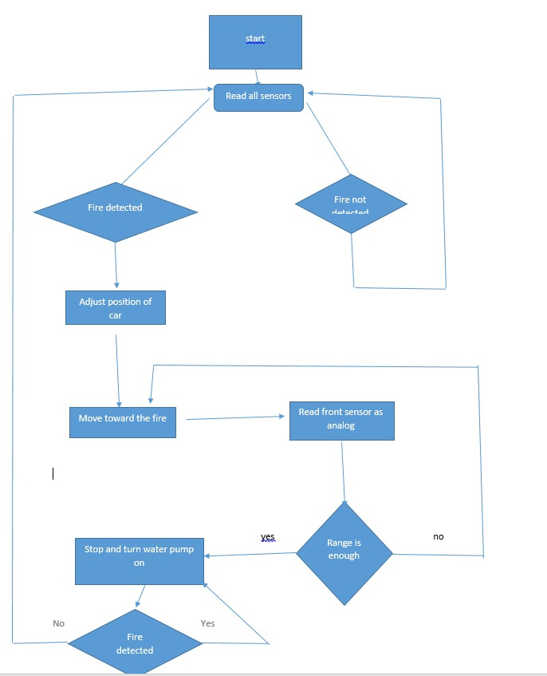

Figure 7 Design

Figure 8 shows the electrical schematic of the connected ports with the PIC16F877A.

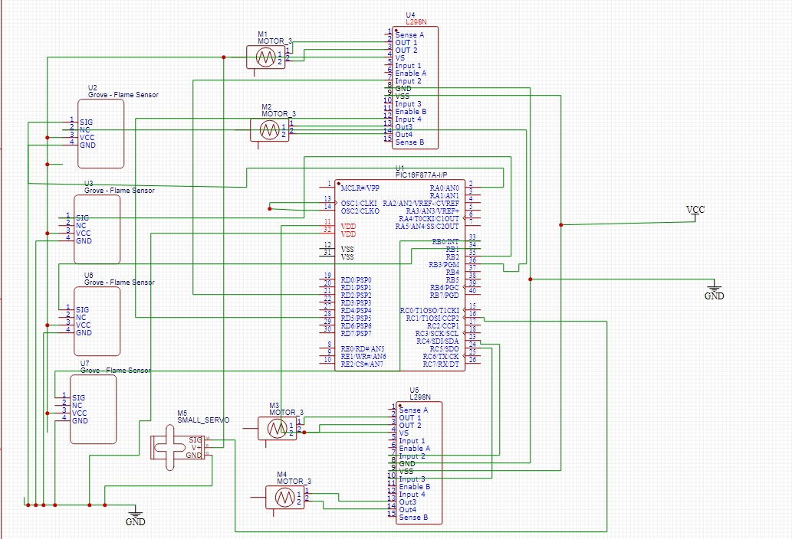

Figure 8 Electrical scheme

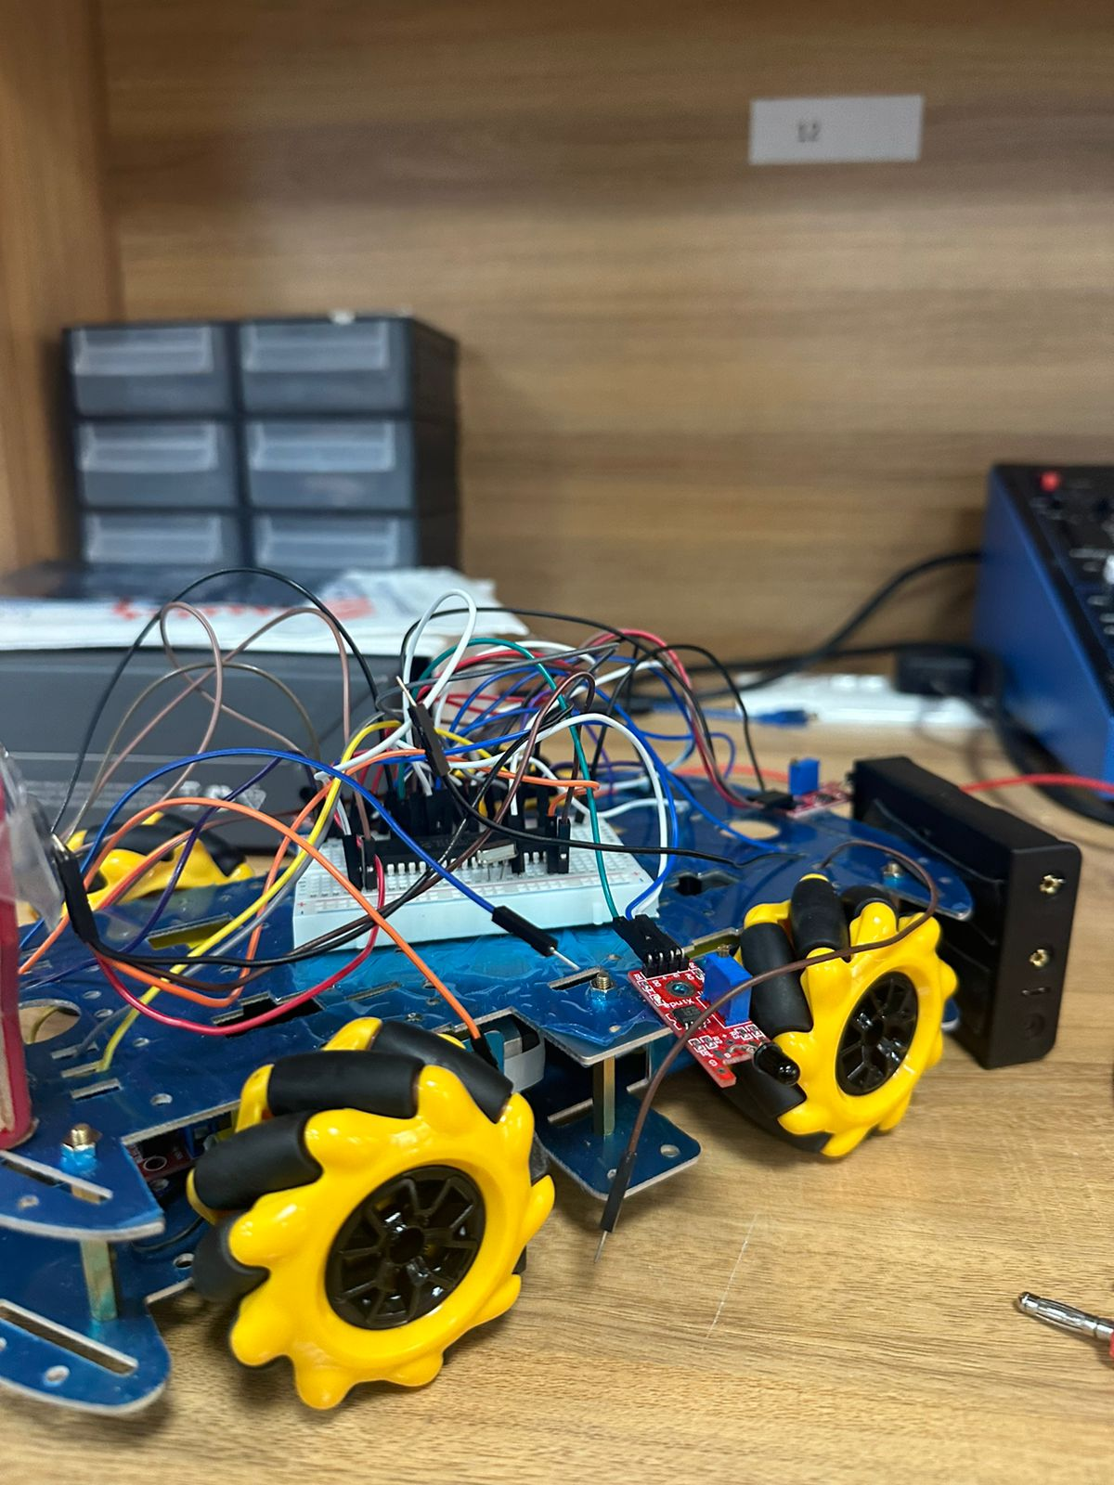

Figure 9 Firetruck

# Problems and recommendations

## problems

1. When we connected a relay to the pic it made a short a circuit or something that made the sensors stay off and not working
2. Overheating: Continuous operation or high ambient temperatures may cause components, especially the PIC16F877A or other integrated circuits, to overheat, reducing their performance or lifespan.
3. Power Supply Instability: Inadequate power supply or fluctuations in voltage can affect the proper operation of the PIC16F877A and other components in the circuit, leading to erratic behavior or malfunction.

## Recommendations

1. Connect the relay to a transistor and a resistor to make the sensors work efficiently.
2. Thermal Management: Implement proper heat sinking or ventilation measures to dissipate heat generated by components, especially the PIC16F877A. Ensure adequate airflow and avoid enclosing components in a confined space to prevent overheating.
3. Voltage Regulation: Use a stable and regulated power supply to ensure consistent voltage levels for the PIC16F877A and other components. Incorporate voltage regulators or voltage monitoring circuits to protect against power supply instability.

# Conclusions

Overall, the PIC 16F877A MCU alongside the flames sensor ky-026 we used for our firetruck robot allows the detection and reaction to flames. The robot navigates effectively by combining digital and analog flame sensors with precision motor control. The project showcases a straightforward but efficient method and demonstrates the usefulness of automation in firefighting circumstances.